Factors affecting Rate of Reaction
1. Concentration
The higher the concentration of a solution the ………………………….. the rate of reaction.
This is because a higher concentration means there are ………………….. particles per unit volume of solution.
This means there are more frequent ……………………. between reactant particles.
For gases, an ............................... in pressure has the same effect. Higher pressure means …………………………
particles per unit volume of gas and therefore a …………………………… collision frequency.

2. Surface area
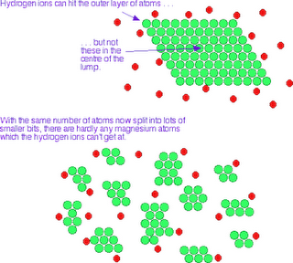
The larger the surface area the……………………. the rate.
This is because a larger surface area means there
are more particles that are available to …………………….
and react.

Diagram showing the reaction between magnesium and acid for different size pieces of magnesium. Notice that the mass and therefore the total number of particles is the same in each case.

3. Temperature
The higher the temperature the …………………….. the rate of reaction. This is for two reasons:
At higher temperatures the particles have more …………………………………………… so move ………………….. and …………………
more frequently. Also, at higher temperatures the increased energy of the reactant particles means that a greater
proportion have the …………………………….. energy, so ………………… when they collide.

4. Catalysts
Catalysts increase the rate of reaction but are not………………………………... . This means that they can be reused.
The greater the mass of catalyst the ……………………… the rate. This is because catalysts provide a ……………………
for the reaction to take place on, ……………………….. the activation energy so that a greater proportion of the
reactants have the activation energy and …………………… when they collide.

